**1 Feb 2019** **The Weekly Bulletin of Rotary Club of Kathmandu Mid-Town** **bc-19.2/019**

|  |
| --- |
| C:\Users\Public\Documents\RIP T1819_EN.png |

District: 3292 Web:www.rotarymidtown.org.np Club Id: 26776

**FEBRUARY IS PEACE AND CONFLICT PREVENTION/RESOLUTION MONTH**

**The Rotary Foundation promotes the practice of peace and conflict prevention/resolution by:**

- Strengthening local peace efforts

- Training local leaders to prevent and mediate conflict

- Supporting long-term peace building in areas affected by conflict

- Assisting vulnerable populations affected by conflict, particularly children and youth

- Supporting studies related to peace and conflict resolution

**Club’s Weekly Meeting # 1474 held on Friday 25 Jan 2019**

Guest speakers Ms Anita Rijal and Mr Stephen Kovats talked about Nepal Communitere, an Innovation hub and resource center to strengthen Nepali innovation projects and build them into successful businesses. Mr Stephen Kovats highlighted on ASKotec (Access to Skills and Knowledge open tech emergency case) a mobile technical platform deployable anywhere regardless of access to electricity/internet. ASKotec was introduced to Nepal at the Kathmandu Mini Maker Fair in 2018.

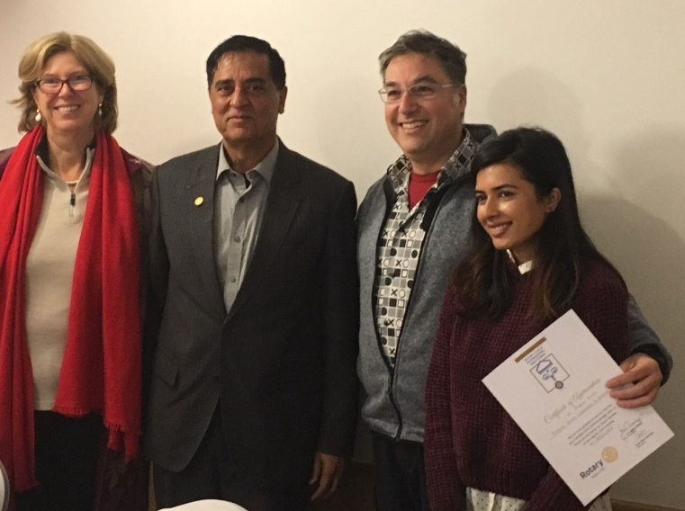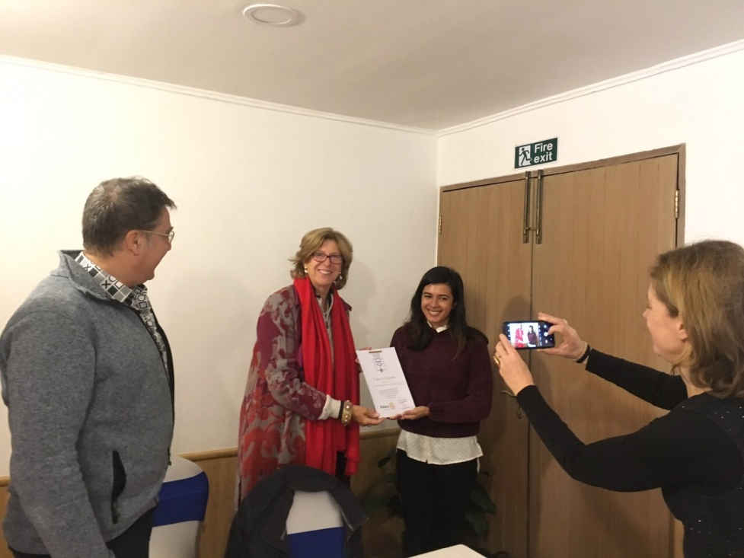

Officiating President Bhai Raja and Vice President Lisa provided Certificate of appreciation to guest speakers - Stephens and Anita

*Photo courtesy: Rtn Shyam R Thapalia*

**Club Meeting # 1475 Friday 1 Feb**

Ms Rita Kharel, the founder of Brahmasthani Awareness Society, will be the guest speaker. BAS was established in 2001 with sole objective of helping poor sick people, disabled people unable to get basic health care and without shelter. Ms Rita Kharel will be talking about BAS : its activities, capacity building, its plan and its shortcomings etc. She will be assisted in her presentation whenever needed by her colleague Raj Kharel who has been associated with the BAS for many years, currently as a Board member.

**RID 3292 District Conference 2019:**



**11th District Conference is scheduled to be held in Butwal, 22 - 24 February 2019.**

Registration fee (Rs) Jan 1-Feb 15 2019 Spot Registration

Rotarian/Guest 6,500 7,000

Rotarian with non-Rotarian spouse 12,000 13,000

Rotaract/Interact/RCC 3,000 3,500

For more information, contact:

Rom Sharma (Conference Office Secretary); districtconference019@gmail.com

Tanka P. Pokharel (Registration Sub-Committee Chair): mobile: 9857021325

**Institute for Economics and Peace:**

The Institute for Economics and Peace is the world’s leading think tank dedicated to developing metrics to analyse peace and to quantify its economic value. It does this by developing global and national indices, calculating the economic cost of violence, analysing country level risk and understanding positive peace.

Rotary International is working with the [Institute for Economics and Peace](http://economicsandpeace.org/) to create an online learning platform, with webinars and interactive tools, that Rotary Club members and Rotary Peace Fellows can use to build on their expertise. Rotary and the institute will also develop positive peace workshops, funded by global grants and hosted by Rotary clubs, to provide training in the framework of positive peace.

**Positive Peace**

Peace is much more than the absence of violence. Positive Peace describes the attitudes, structures and institutions that underpin and sustain peaceful societies. The Institute has developed a conceptual framework, known as the Pillars of Peace, that outlines a system of eight factors that work together to build positive peace. Derived from a statistical analysis of over 5,000 datasets, the Pillars of Peace provides a roadmap to overcome adversity and conflict, and to build lasting peace.

*Read more on http://economicsandpeace.org*

**Do you Know** **?**

**Dog licks man, man requires amputation!**

Dog owners tell themselves their pets would never do anything to intentionally harm them. Unfortunately, a Wisconsin man named Greg Manteufel learned the hard way that he probably shouldn't have let his best friend lick him too much. After being admitted to a hospital, Manteufel was found to be suffering from an infection by a bacteria called *Capnocytophaga*, which led to the amputation of his legs and parts of his arms. The bacteria live in most household pets without causing problems, but if they get passed to a human via a bite or scratch and spread through a person's bloodstream, they can cause deadly consequences. Dr. Silvia Munoz-Price, an infectious-disease specialist told Live Science that the case is extremely rare. "More than 99 percent of the people that have dogs will never have this issue. It's just chance," she said.

*Read more on https://www.livescience.com*

**A THOUGHT FOR THE DAY**

“I know of no single formula for success. But over the years I have observed that some attributes of leadership are universal and are often about finding ways of encouraging people to combine their efforts, their talents, their insights, their enthusiasm and their inspiration to work together.”

- Queen Elizabeth II

On Lighter Side:

One day my mother was out and my dad was in charge of me. Someone had given me a little 'tea set' as a get-well gift and it was one of my favourite toys. Daddy was in the living room engrossed in the evening news when I brought him ‘a little cup of tea', which was just water. After several cups of tea and lots of praise for such yummy tea, my Mum came home.

My Dad made her wait in the living room to watch me bring him a cup of tea, because it was just the cutest thing! My Mum waited and, sure enough, I came down the hall with a cup of tea for Daddy. My mum watches him drink it up, and then she says: Did it ever occur to you that the only place she can reach to get water is the toilet?

Change is hard. And the longer we've been going one way, the more friends we have with us,

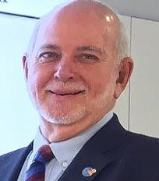

the harder it is to be the one who turns around and does it differently. But change — not

change for its own sake, but careful, considered, goal-directed change — is essential for any

organization that wants to evolve, stay relevant, and move forward in the right direction.

**RI President Barry Rassin**

Please send information on club activities, progress reviews on service projects, relevant photos etc to:

BC Editor: RR Shrestha email: rryesrr@gmail.com

## 1 Feb 2019 The Weekly Bulletin of Rotary Club of Kathmandu Mid-Town bc-19.2/019